TEST: FORD ECOSPORT FREESTYLE 1.6 - THE REUNION AFTER 20,000 KM
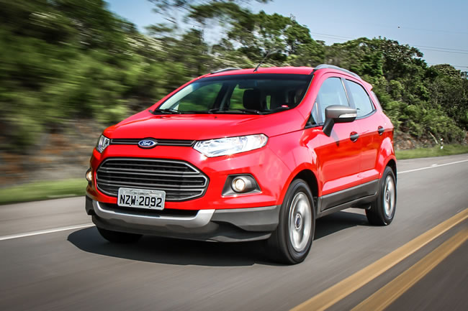
0 km test car is a beauty: smell again and everything running in perfect order. But when we take a more rotated, sometimes we realize that not all qualities of the vehicle fresh out of the factory were kept. So I was happy to see that the EcoSport FreeStyle 1.6 sent for testing CARPLACE had over 20 thousand km run. As I had already been a few times in units with low mileage, the reunion would serve to confirm (or not) the virtues (and defects) of the jeep.
In Eco old, especially the first batch (until 2007), it was common for owners complain of noises and crashes finishing after some time of use. Apparently, the new model evolved in the quality of materials and construction presents a far more elaborate - even if that unit tested, the pre-series, has a large gap in the bodywork back cover that is fixed by Ford in "batches" following. In fact, the car remains fairly intact after more than 20,000 km and recalls that this mileage was covered in tests with journalists, who generally require more car. Because we did not find anything parasitic noise or undocked finishing pieces - at most a few scratches on the hard plastic panel. The only problem was the rubber driver's door. Happened to the glass plates, with anti-crush, when it came down to the door jamb, requiring the user to hold the button until the window closes for good. This also precluded the use of "global closing" by the remote control key, because the driver's window closed and opened again.
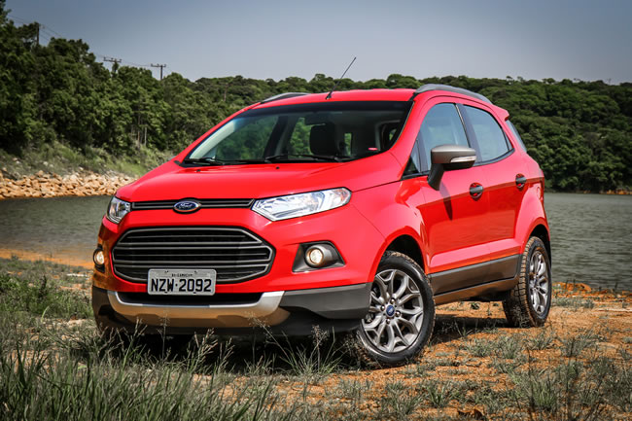
The reunion with Eco also confirmed its good played. Reminds me of a New Fiesta (car which I consider one of the best to drive in its class) with the suspension and the position of guiding high.The electric steering is well calibrated the highlight: soft and mild maneuvers, rapid and correct weight on the road, and still able to absorb impacts without wheels loosing communication with the driver. The 1.6 16V engine Sigma also serves well the jeep, coupled with exchange of good couplings. There is good supply of torque at low rpm (80% of 15.9 Nm is available at 1,500 revs), which makes the smart car in traffic. He bends the corner and passes on spines of third gear, without choking. In our test, the acceleration from 0 to 100 km / h in 12.2 s was accomplished - time also much lighter car with 1.6 engine. On highways, you will only miss of power (115 hp with ethanol are) if the car is full. Other than that, the performance is good, and to 120 km / h in fifth gear, the engine works slightly above 3,000 rpm, without intruding on the conversation in the cockpit.
Sigma Another advantage is the smoothness of operation. You can explore almost the limit spins the propellant does not appear harsh or excessively noisy. In addition, fuel economy continues to attract attention, even in a heavier car like the Eco Both have recorded good average of 8 km / l in the city and 11.2 km / l on the road, always with ethanol. For the optimal balance in performance relative x consumption, the Eco 1.6 is the best option line. I just take the 2.0 case traveled a lot with the car loaded or opt for the version with exchange Powershift dual clutch.
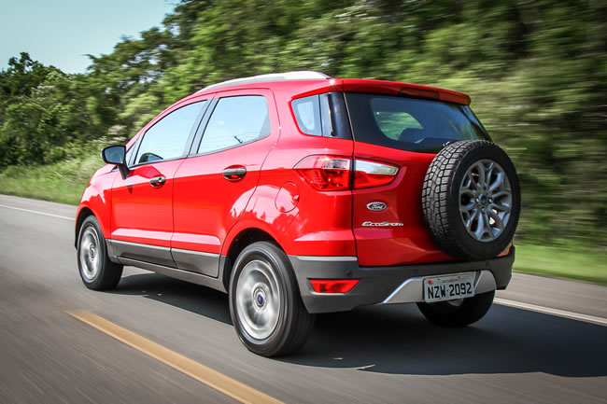
If the engine does not miss the old leaves Rocam 1.6, the suspension can divide opinions. In my view, the class took advantage of the dynamic behavior on the comfort. The new Eco was more balanced cornering and fast deviations, despite the high center of gravity, but the suspension travel was reduced, reaching the limit on holes where the old model did not complain. The rival Renault Duster, for example, is much softer, but more balance in curves - word of someone who has traveled with the two for more than 1,000 km. Not that the Echo has lost the appetite to run over potholes and ditches, but if you take a dirt road or a bumpy stretch too, will feel the impacts more than the old model. Flooded to a depth of up to 450 mm can also be crossed, if in compliance with the maximum speed of 7 km / h during the trip.
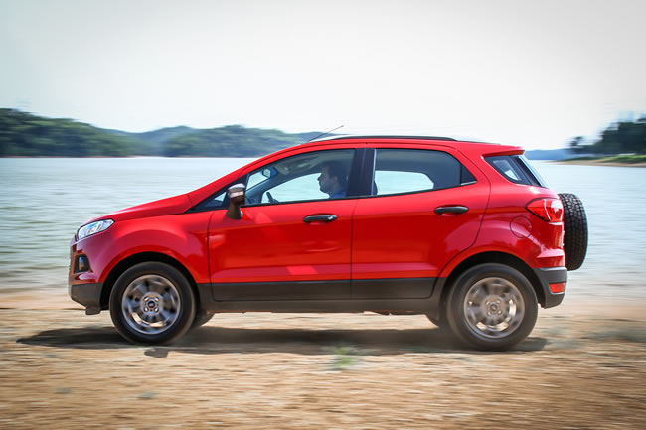
Life on board was favored by increasing the wheelbase. Who's after now has more space, especially in the area for the legs and head, besides having the backrest adjustment. Four adults and one child traveling comfortably. One limitation for those who think like the Eco family car, however, is in the trunk. Officially, the capacity increased from 296 to 362 liters, but in the real magazine lost depth (the gain was at the time), which complicates the time to put bags and large objects. Another felt was lack of storage compartments in the back cover that existed in the previous model. The cap continues with side opening, now with built-in flashlight handle curiously.The following steppe outside, according to Ford through consumer choice in clinics.
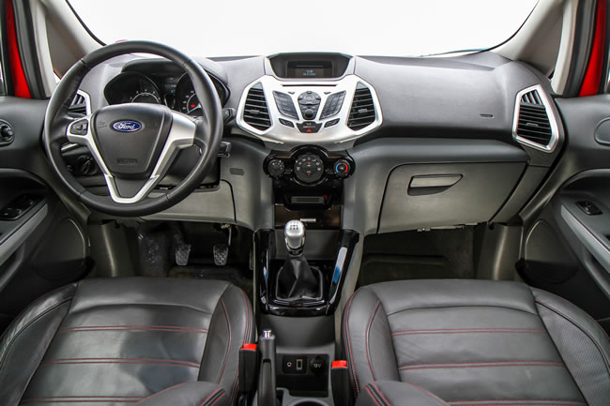
In front of the accommodation is good, but the seats could be a little longer for better thigh support. The front speakers steeper gave a good sense of space in front of the driver, who stole only part of the side view, requiring some custom. The driving position is favored by adjustments of height and depth direction, commanded by a good grip steering wheel, shift lever and the high.There are good internal solutions like two bottle holders in the front doors and the little drawer under the passenger seat, but there is a lack of ergonomics: the control of power windows is in a very advanced position in the driver's door. It's easy to open the windows back unintentionally when you want to open the front.
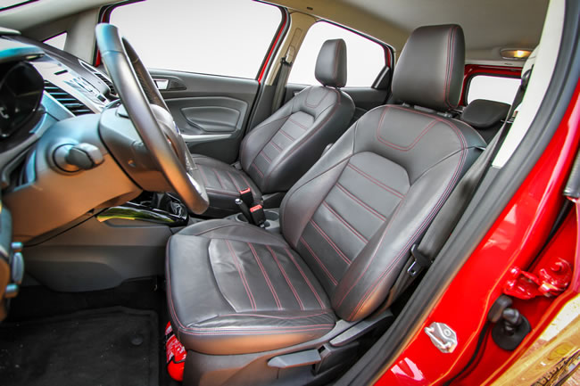
The Sync entertainment system also requires some adjustment at first until you become familiar with all functions, but like the good sound quality and the presence of Bluetooth and USB.Informants linked to indicate that Ford is developing an option for built-in GPS for short (now that the Duster won this option), and the sun roof - things that can paint the model 2014. FreeStyle This version comes equipped with stability control (which operates discreetly in the ceiling) and assistant interesting exit ramps, which "holds" the car as the driver releases the clutch. The list of standard features also include dual airbags, ABS brakes, sound commands on the steering wheel with LED headlights, wheel rim 16 and parking sensor. The only option is the set of side airbags leather jacket with the banks, which raises the price of R $ 61,500 to R $ 65,300. For the complete car as evaluated the price reaches overcome the SE version 2.0 Powershift, which costs U.S. $ 64,960 and offers stronger engine and more sophisticated exchange.
Despite losing the appeal of "affordable SUV" (today the Duster is cheaper), it is undeniable that the new generation of Eco took a giant leap in quality and drivability, and rekindle the flame aspirational consumer with a stylish design and modern. The fact to keep in good condition after the 20,000 kilometers of tests is a good indicator for who thinks up a new semi-Eco. With the model 0 Km beating sales records, soon the used market will be full of good options.
